This is the concise and catchy title of my abstract in Arial, bold face, 14 typographic points high
Presenting author 1, co-authors
ebs2021@th-wildau.de (Corresponding e-mail address)
¹Affiliation of the authors, Institute, University, Street and number, Postal Code City, Country
Abstract: The abstract should be no longer than 1 side and written in a clear and appealing style. Even colleagues, who are not really a specialist in your field, will find it worthwhile to listen to your lecture or visit your poster. The largest part of the abstract should be devoted to the obtained results. Please use the letter size 11 and keep the indicated frames.

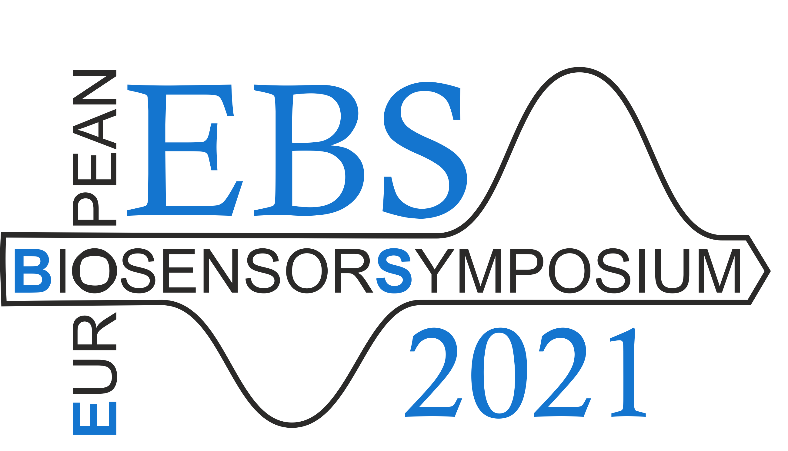
Figure 1: The Figure caption. Please give a short and precise description. The figure should be in good printing quality.
References
- F. Lisdat, D. Schäfer, A. Kapp, Anal. Bioanal. Chem. 2013, 405, 3739 – 3752.
- Bard, A. J.; Faulkner, L. R. Electrochemical Methods, 2nd ed.; Wiley: New York, 2001.

